DAD 220 Project One

Complete these steps as you work through the directions for Project One. Replace the bracketed text with your screenshots and brief explanations of the work they capture. Each screenshot and its explanation should be sized to approximately one-quarter of the page with the description written below the screenshot. Follow these rules for each of the prompts and questions below. Review the example document in the Supporting Materials section of the Project One Guidelines and Rubric for assistance.

Step One: Create a Database

- In your online IDE (Codio), create a database schema called QuantigrationUpdates that will hold tables by using SQL commands.
  - List out the database name on the screen.
  - Provide the SQL commands you ran against MySQL to complete this step.

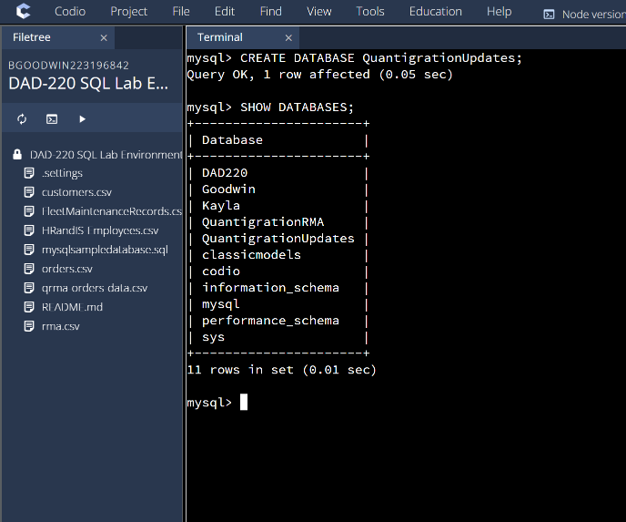
I used the create database command to create a new database named QuantigrationUpdates then used the show databases command to display what databases are in the system.

- Connect to the QuantigrationUpdates schema. Using the ERD as a reference, write SQL commands to create the following tables with the appropriate attributes and keys to demonstrate relationships based on the ERD.
  - A table named Customers to store customer information with a primary key of Customer ID. Provide the SQL commands you ran against MySQL to complete this step.

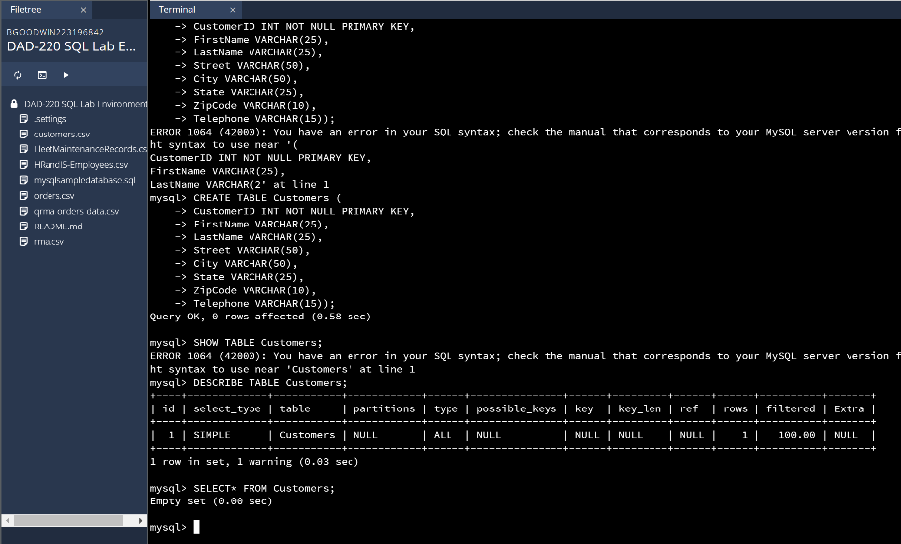
I used the create table command then set up the table with the parameters for each column making the CustomerID column the primary key.

  - A table named Orders to store order information with a primary key of Order ID and a foreign key of Customer ID. Provide the SQL commands you ran against MySQL to complete this step.

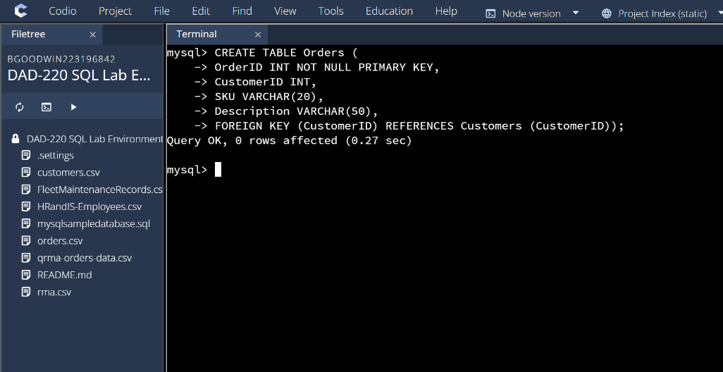
I used the create table then entered in the value for each column, making the orderID the primary key; I also made CustomerID a foreign key and referenced it to the Customers table then connected it with the primary key of CustomerID.

  - A table named RMA to store RMA information with a primary key of RMA ID and a foreign key of Order ID. Provide the SQL commands you ran against MySQL to complete this step.

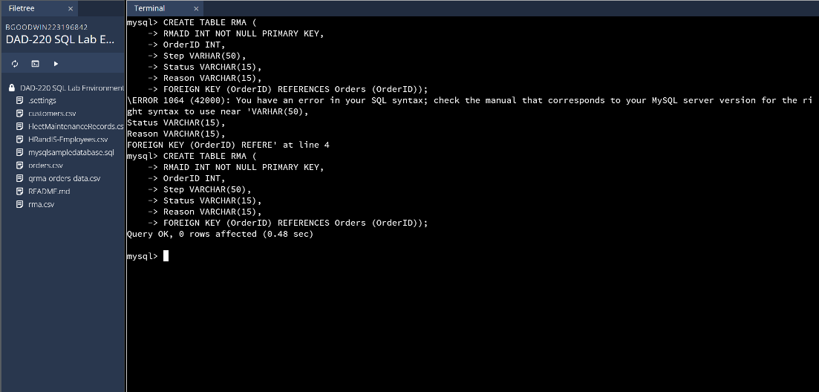
I used the create table then entered in the value for each column, making the RMAID the primary key; I also made OrderID a foreign key and referenced it to the Orders table then connected it with the primary key of OrderID.

Step Two: Load and Query the Data

- Import the data from each file into tables.
  - Use the QuantigrationUpdates database, the three tables you created, and the three CSV files preloaded into Codio.
  - Use the import utility of your database program to load the data from each file into the table of the same name. Perform this step three times, once for each table.
  - Provide the SQL commands you ran against MySQL to complete this step.

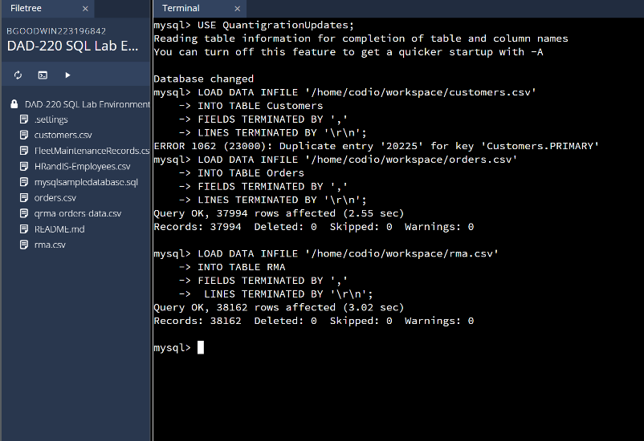
I used the load data in file from the csv into the appropriate table separating each piece of information with a comma and spreading out each line with a new space which made it fit into the appropriate columns and rows.

- Write basic queries against the imported tables to organize and analyze the targeted data. For each query, replace the bracketed text with a screenshot of the query and its output. Also, include a one- to three-sentence description of the output.
  - Write a SQL query that returns the count of orders for customers located only in Framingham, Massachusetts.
    - This query will use a table join between the Customers and Orders tables. The query will also use a WHERE clause.
    - How many records were returned?

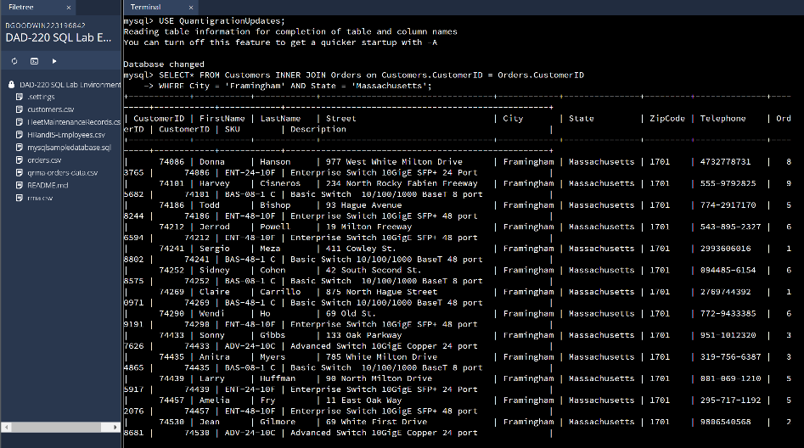
I selected all from the customers table then joined the customers table with the orders table and had it only return orders that were from Framingham Massachusetts The number of records that were returned are 505.

  - Write a SQL query to select all of the customers located in Massachusetts.
    - Use a WHERE clause to limit the number of records in the Customers table to only those who are located in Massachusetts.
    - How many records were returned?

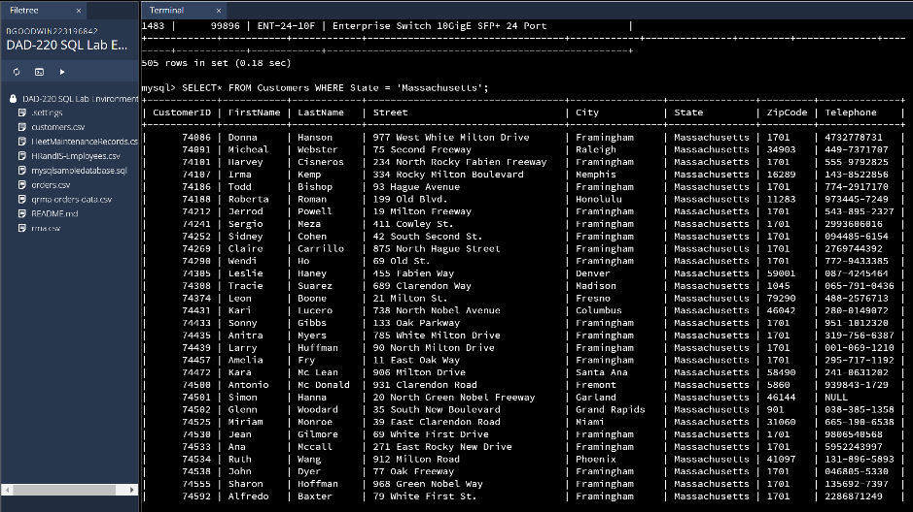
I selected all from the Customers table with the restriction that it returns only customers from the state of Massachusetts. The number of records returned were 982.

  - Write a SQL query to insert four new records into the Orders and Customers tables using the data below:

Customers Table
CustomerID | FirstName | LastName | StreetAddress | City | State | ZipCode | Telephone
100004 | Luke | Skywalker | 15 Maiden Lane | New York | NY | 10222 | 212-555-1234
100005 | Winston | Smith | 123 Sycamore Street | Greensboro | NC | 27401 | 919-555-6623
100006 | MaryAnne | Jenkins | 1 Coconut Way | Jupiter | FL | 33458 | 321-555-8907
100007 | Janet | Williams | 55 Redondo Beach Blvd | Torrence | CA | 90501 | 310-555-5678

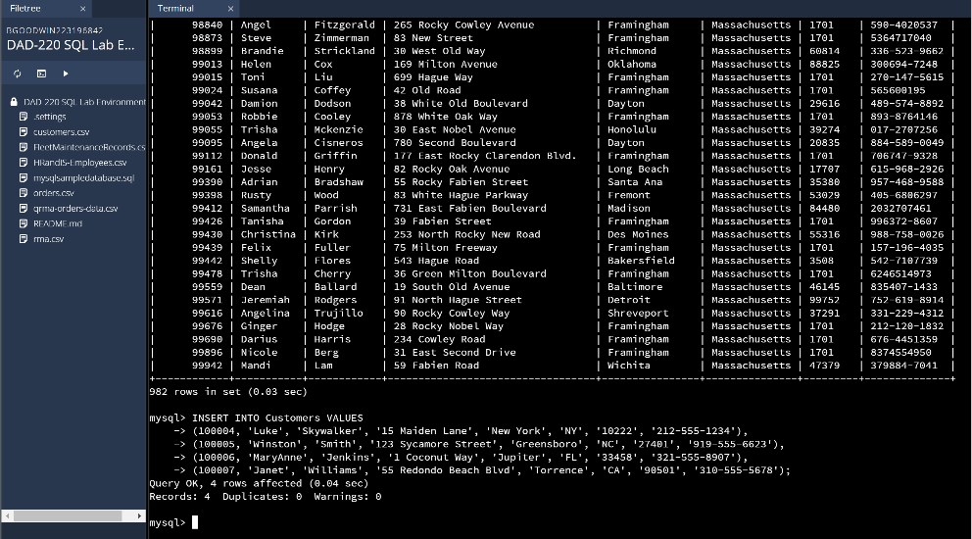
I used the insert into customer table so it knows where the information is going then the values command to let it know I was entering information to the table, Then I filled out the information accordingly with each column it corresponds with.
Orders Table
OrderID | CustomerID | SKU | Description
1204305 | 100004 | ADV-24-10C | Advanced Switch 10GigE Copper 24 port
1204306 | 100005 | ADV-48-10F | Advanced Switch 10 GigE Copper/Fiber 44 port copper 4 port fiber
1204307 | 100006 | ENT-24-10F | Enterprise Switch 10GigE SFP+ 24 Port
1204308 | 100007 | ENT-48-10F | Enterprise Switch 10GigE SFP+ 48 port

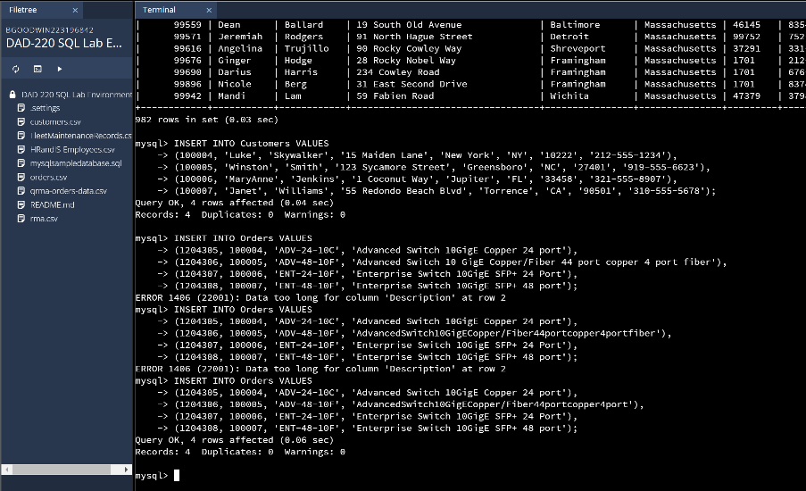
I used the insert into Orders table so it knows where the information is going then the values command to let it know I was entering information to the table, Then I filled out the information accordingly with each column it corresponds with.

  - In the Customers table, perform a query to count all records where the city is Woonsocket and the state is Rhode Island.
    - How many records are in the Customers table where the field "city" equals "Woonsocket"?

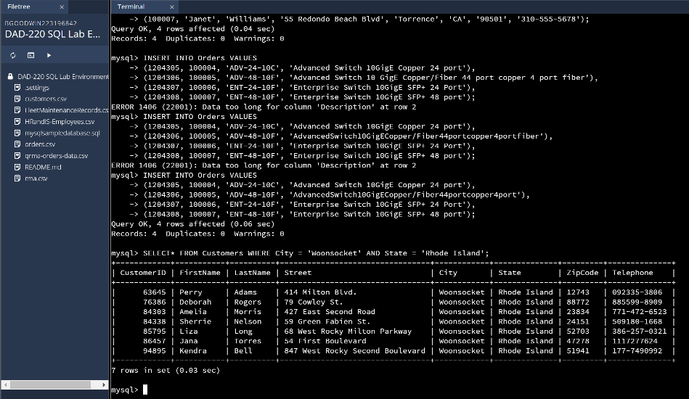
I selected all from the Customers table with the restriction that it returns only customers from the state of Rhode Island and the city of Woonsocket. The number of records returned was 7.
  - In the RMA database, update a customer's records.
    - Write a SQL statement to select the current fields of status and step for the record in the RMA table with an OrderID value of "5175".
      - What are the current status and step?

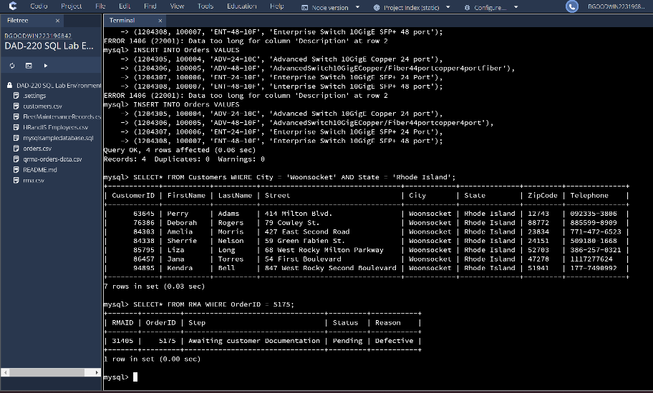
I selected all from the RMA table where the Order ID is 5175 which returned that the status is Pending and the step is Awaiting customer Documentation.

    - Write a SQL statement to update the status and step for the OrderID, 5175 to status = "Complete" and step = "Credit Customer Account".
      - What are the updated status and step values for this record?

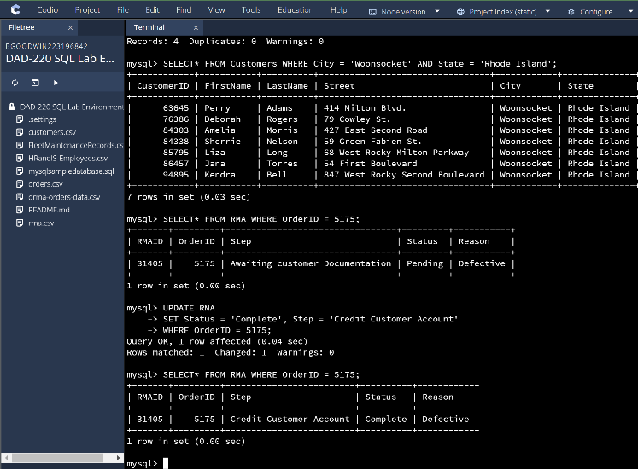
The updates status is now complete and the updated step is now “Credit Customer Account” by using the update command on the table Orders where OrderID is 5175.
  - Delete RMA records.
    - Write a SQL statement to delete all records with a reason of "Rejected".
      - How many records were deleted?

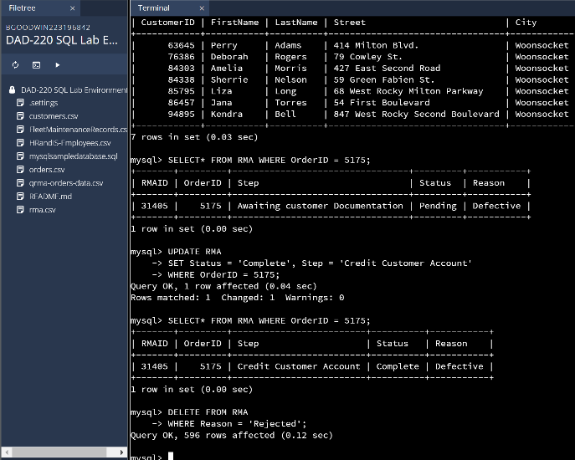
I used the delete command from the table RMA and set the restriction to delete records that have a reason of rejected which deleted 596 rows.

- Update your existing tables from "Customer" to "Collaborator" using SQL based on this change in requirements. Copy and paste the SQL you write to do the following action:
  - Rename all instances of "Customer" to "Collaborator".

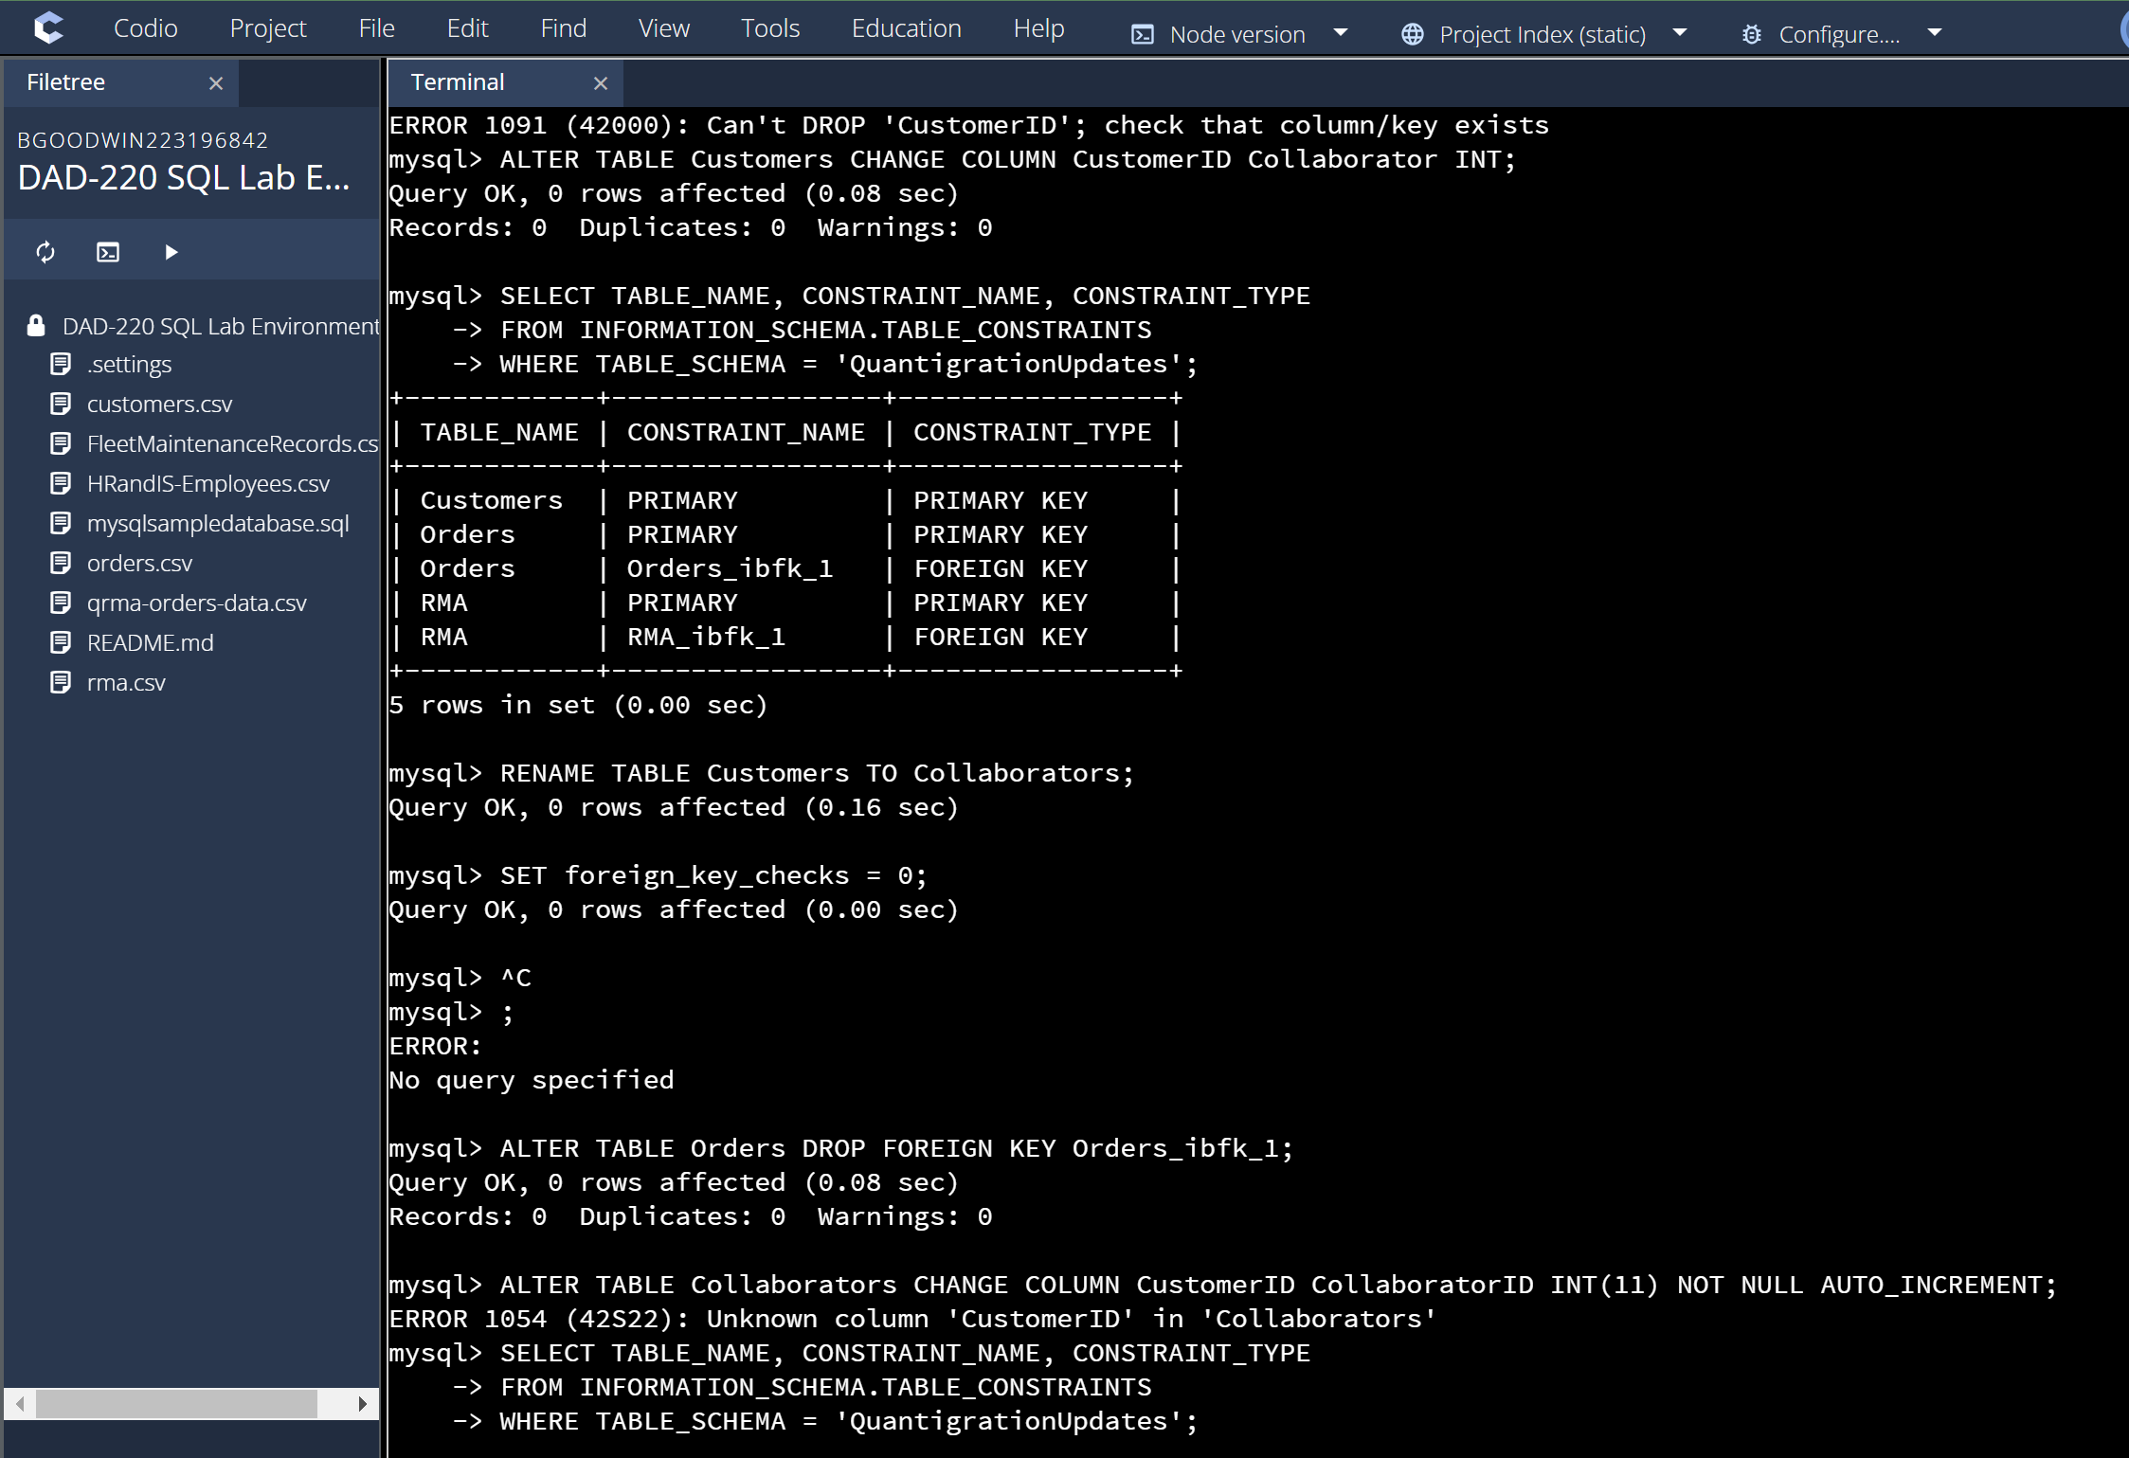
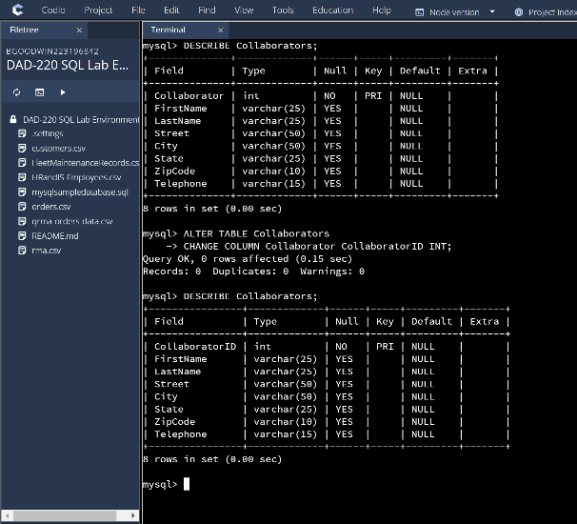
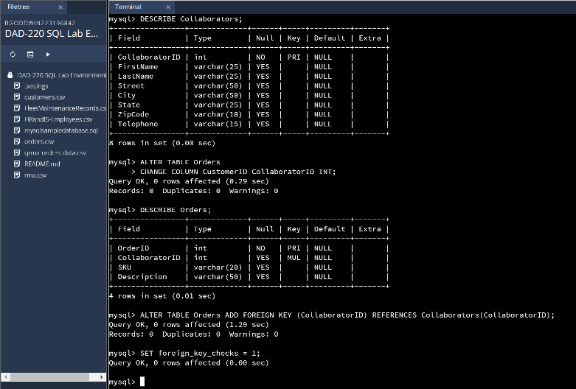
I altered the table and changed the name from Customers to Collaborator then dropped the foreign key restrictions so that I could change the CustomerID column in both tables to Collaborator ID. Lastly, the foreign key was reestablished so that the tables could be connected and work properly.

- Create an output file of the required query results. Write a SQL statement to list the contents of the Orders table and send the output to a file that has a CSV extension.

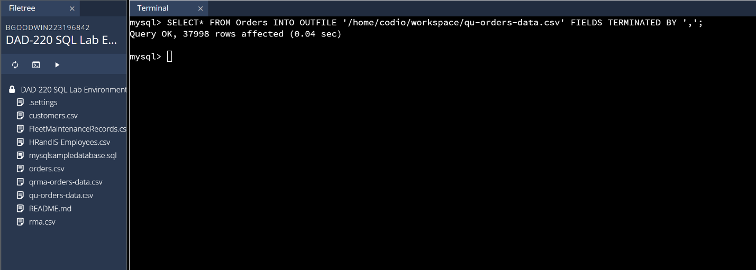

I selected the data from the Orders table and converted it into an out file csv and had the information separated by commas so it could be loaded into another table or viewed properly if necessary.

